**Objective** - The assignment is meant for you to apply learnings of the module on Hive on a real-life dataset. One of the major objectives of this assignment is gaining familiarity with how an analysis works in Hive and how you can gain insights from large datasets.

**Problem Statement** - New York City is a thriving metropolis and just like most other cities of similar size, one of the biggest problems its residents face is parking. The classic combination of a huge number of cars and a cramped geography is the exact recipe that leads to a large number of parking tickets.

In an attempt to scientifically analyse this phenomenon, the NYC Police Department regularly collects data related to parking tickets. This data is made available by NYC Open Data portal. We will try and perform some analysis on this data.

**Download Dataset - <https://data.cityofnewyork.us/browse?q=parking+tickets>**

**Note**: Consider only the year 2017 for analysis and not the Fiscal year for year 2017 only/

create table parking_violation_temp

(

summons_number bigint,

plate_id string,

registration_state string,

plate_type string,

issue_date date,

violation_code int,

vehicle_body_type string,

vehicle_make string,

issuing_agency string,

street_code_1 int,

street_code_2 int,

street_code_3 int,

vehicle_expiration_date date,

violation_location int,

violation_precinct int,

issuer_precinct int,

issuer_code int,

issuer_command string,

issuer_squad string,

violation_time string,

time_first_observed string,

violation_country string,

violation_in_front_of_or_opposite string,

house_number string,

street_name string,

intersecting_street string,

date_first_observed date,

law_section int,

sub_division string,

violation_legal_code string,

days_parking_in_effect string,

from_hours_in_effect string,

to_hours_in_effect string,

vehicle_color string,

unregistered_vehicle int,

vehicle_year int,

meter_number string,

feet_from_curb int,

violation_post_code string,

violation_description string,

no_standing_stopping_violation string,

hydrant_violation string,

double_parking_violation string

)

row format serde 'org.apache.hadoop.hive.serde2.OpenCSVSerde'

with serdeproperties(

"separatorChar" = ",",

"quoteChar" = "\"",

"escapeChar" = "\\"

)

stored as textfile

tblproperties("skip.header.line.count" = "1");

hive> load data local inpath '/home/cloudera/data/Parking_Violations_Issued_-_Fiscal_Year_2017.csv' into table parking_violation_temp;

create table parking_violation

(

summons_number bigint,

plate_id string,

registration_state string,

plate_type string,

issue_date date,

violation_code int,

vehicle_body_type string,

vehicle_make string,

issuing_agency string,

street_code_1 int,

street_code_2 int,

street_code_3 int,

vehicle_expiration_date date,

violation_location int,

violation_precinct int,

issuer_precinct int,

issuer_code int,

issuer_command string,

issuer_squad string,

violation_time string,

time_first_observed string,

violation_in_front_of_or_opposite string,

house_number string,

street_name string,

intersecting_street string,

date_first_observed date,

law_section int,

sub_division string,

violation_legal_code string,

days_parking_in_effect string,

from_hours_in_effect string,

to_hours_in_effect string,

vehicle_color string,

unregistered_vehicle int,

vehicle_year int,

meter_number string,

feet_from_curb int,

violation_post_code string,

violation_description string,

no_standing_stopping_violation string,

hydrant_violation string,

double_parking_violation string

)

partitioned by (violation_country string)

clustered by (violation_code)

sorted by (violation_code)

into 4 buckets

tblproperties("skip.header.line.count" = "1");

insert overwrite table parking_violation partition(violation_country) select summons_number, plate_id, registration_state, plate_type, issue_date, violation_code, vehicle_body_type, vehicle_make, issuing_agency, street_code_1, street_code_2, street_code_3, vehicle_expiration_date, violation_location, violation_precinct, issuer_precinct, issuer_code, issuer_command, issuer_squad, violation_time, time_first_observed , violation_in_front_of_or_opposite, house_number, street_name, intersecting_street, date_first_observed, law_section, sub_division, violation_legal_code, days_parking_in_effect, from_hours_in_effect, to_hours_in_effect, vehicle_color, unregistered_vehicle, vehicle_year, meter_number, feet_from_curb, violation_post_code, violation_description, no_standing_stopping_violation, hydrant_violation, double_parking_violation, violation_country from parking_violation_temp where year(issue_date) = '2017';

The analysis can be divided into two parts:

**Part-I: Examine the data**

1. **Find the total number of tickets for the year.**

select count(summons_number) from parking_violation;

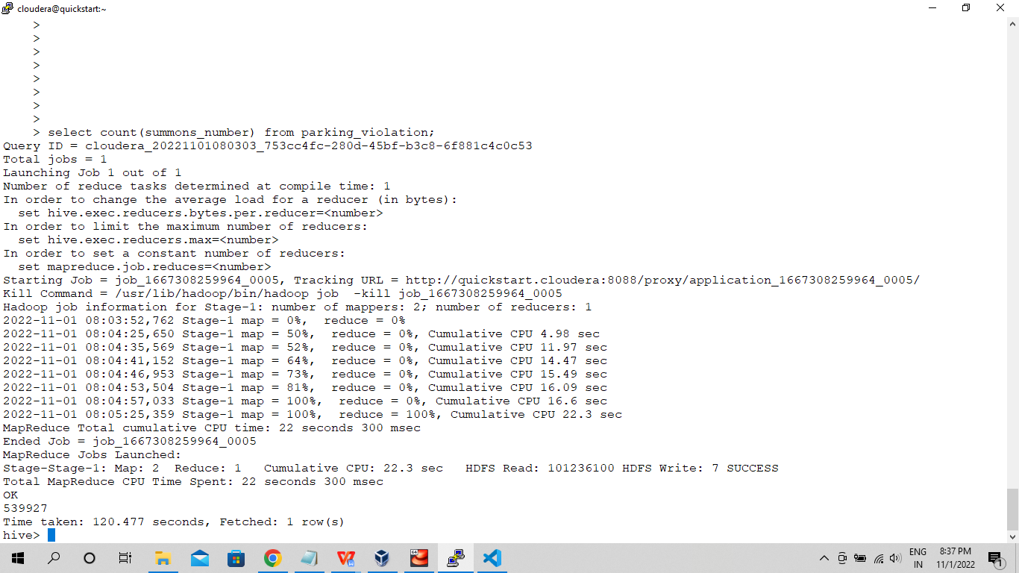

1. **Find out how many unique states the cars which got parking tickets came from.**

select count(distinct(registration_state)) from parking_violation;

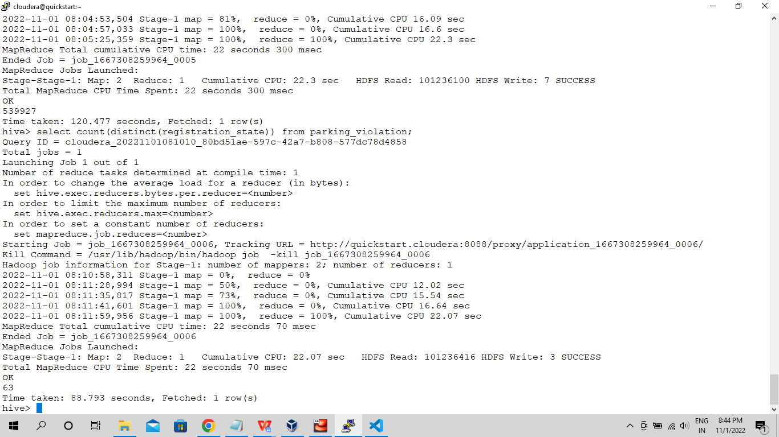

1. **Some parking tickets don’t have addresses on them, which is cause for concern. Find out how many such tickets there are(i.e. tickets where either "Street Code 1" or "Street Code 2" or "Street Code 3" is empty )**

**select count(*) from parking_violation where street_code_1 = '0' or street_code_2 = '0' or street_code_3 = '0';**

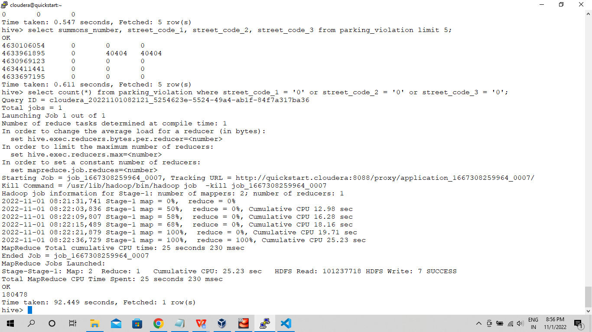

**Part-II: Aggregation tasks**

1. **How often does each violation code occur? (frequency of violation codes - find the top 5)**

select violation_code, count(violation_code) as frequency from parking_violation group by violation_code order by frequency desc limit 5;

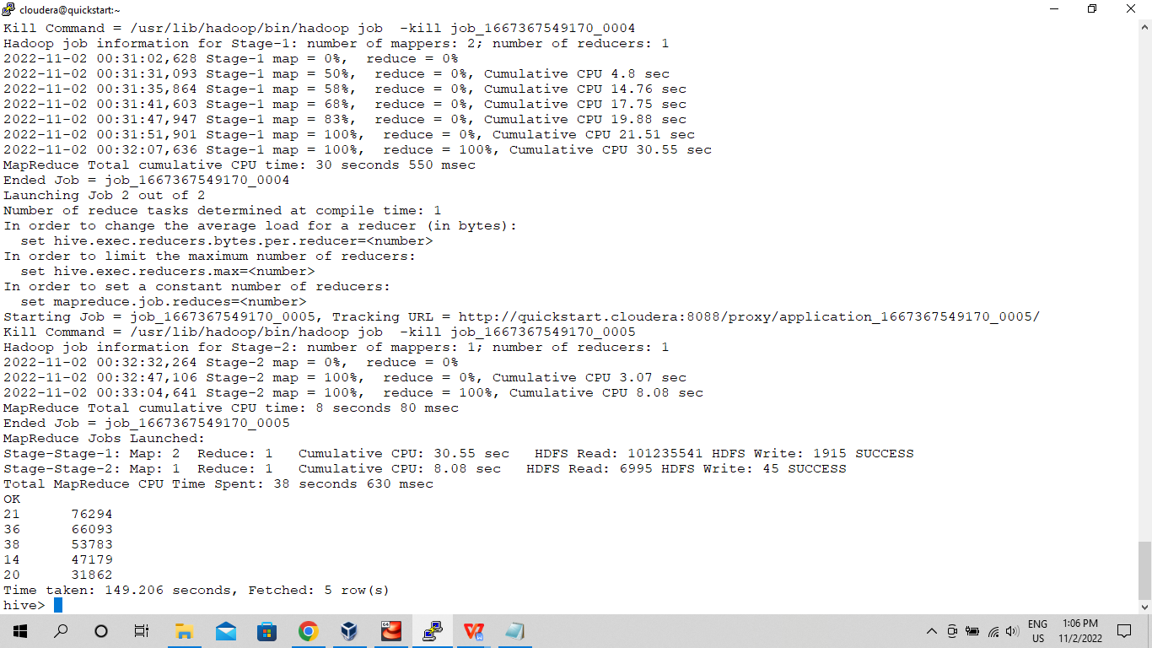

1. **How often does each vehicle body type get a parking ticket? How about the vehicle make? (find the top 5 for both)**

select vehicle_body_type, count(vehicle_body_type) as frequency from parking_violation group by vehicle_body_type order by frequency desc limit 5;

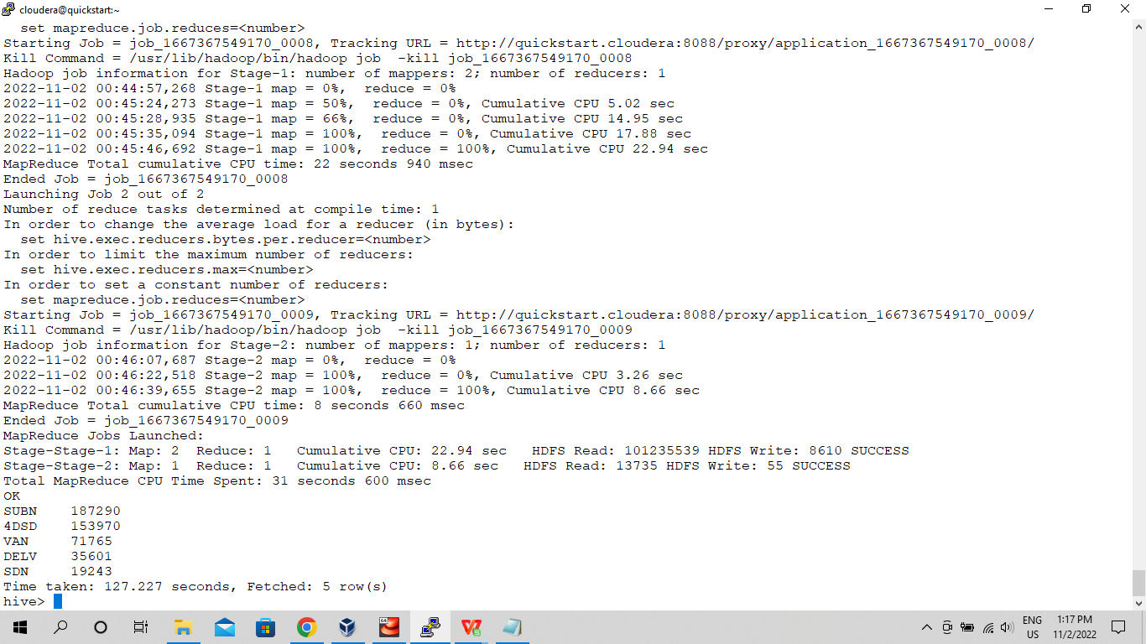

select vehicle_make, count(vehicle_make) as frequency from parking_violation group by vehicle_make order by frequency desc limit 5;

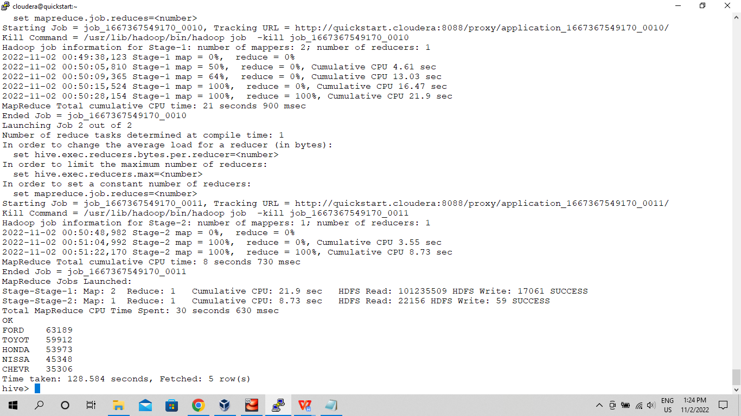

1. **A precinct is a police station that has a certain zone of the city under its command. Find the (5 highest) frequencies of:**
2. **Violating Precincts (this is the precinct of the zone where the violation occurred)**

select violation_precinct, count(violation_precinct) as frequency from parking_violation group by violation_precinct order by frequency desc limit 5;

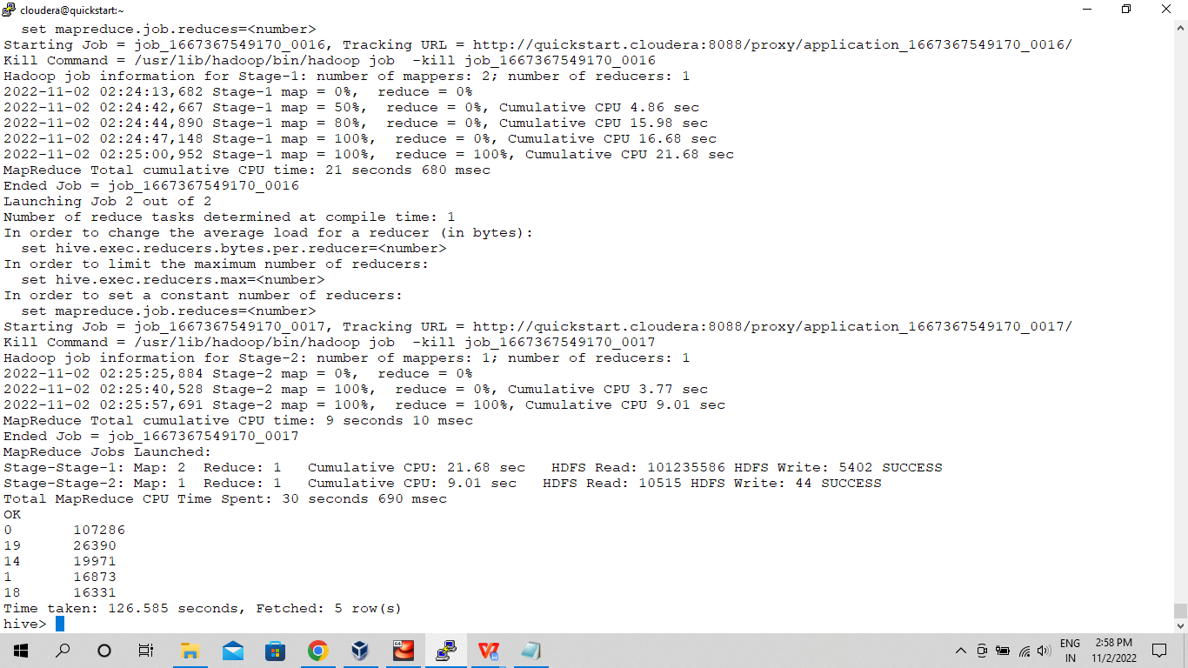

1. **Issuer Precincts (this is the precinct that issued the ticket)**

select issuer_precinct, count(issuer_precinct) as frequency from parking_violation group by issuer_precinct order by frequency desc limit 5;

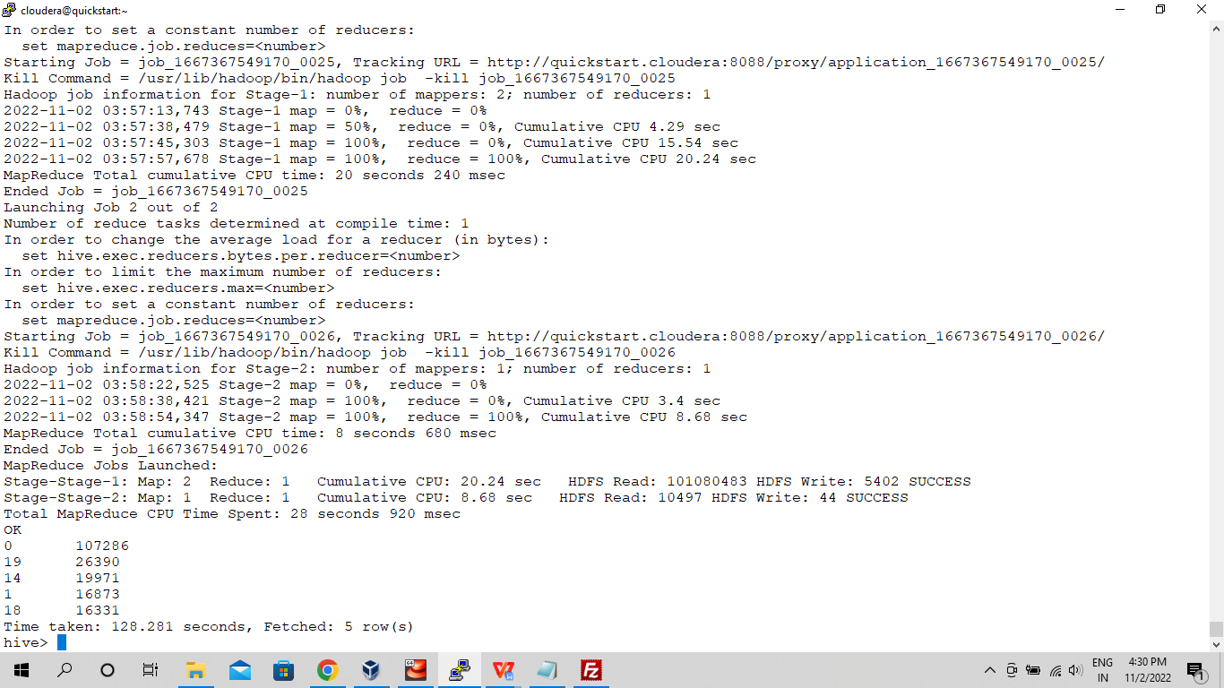

1. **Find the violation code frequency across 3 precincts which have issued the most number of tickets - do these precinct zones have an exceptionally high frequency of certain violation codes?**

select issuer_precinct, count(violation_code) as frequency from parking_violation group by issuer_precinct order by frequency desc limit 3;

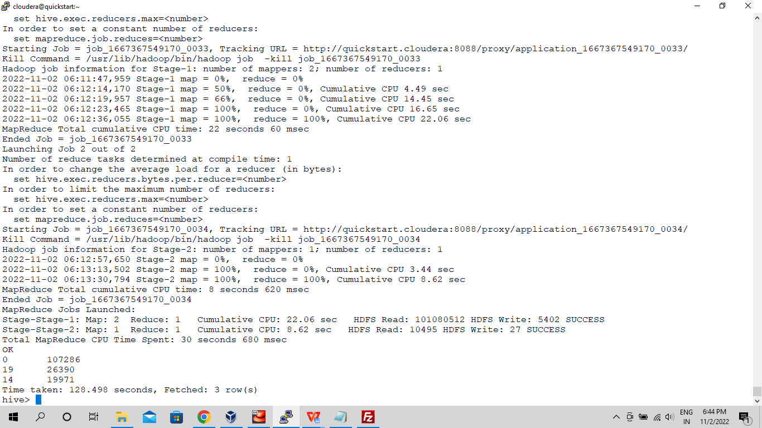

1. **Find out the properties of parking violations across different times of the day: The Violation Time field is specified in a strange format. Find a way to make this into a time attribute that you can use to divide into groups.**
2. **Divide 24 hours into 6 equal discrete bins of time. The intervals you choose are at your discretion. For each of these groups, find the 3 most commonly occurring violations**

create view parking_violations_bins

partitioned on (Violation_Code)

as

SELECT

summons_number,

violation_time,

case

when substring(Violation_Time,1,2) in ('00','01','02','03') and substring(violation_time,-1)='A' then 1

when substring(Violation_Time,1,2) in ('04','05','06','07') and substring(violation_time,-1)='A' then 2

when substring(Violation_Time,1,2) in ('08','09','10','11','12') and substring(violation_time,-1)='A' then 3

when substring(Violation_Time,1,2) in ('00','01','02','03') and substring(violation_time,-1)='P' then 4

when substring(Violation_Time,1,2) in ('04','05','06','07') and substring(violation_time,-1)='P' then 5

when substring(Violation_Time,1,2) in ('08','09','10','11','12') and substring(violation_time,-1)='P'then 6

else null

end as bin,

violation_code

from parking_violation

where

violation_time is not null;

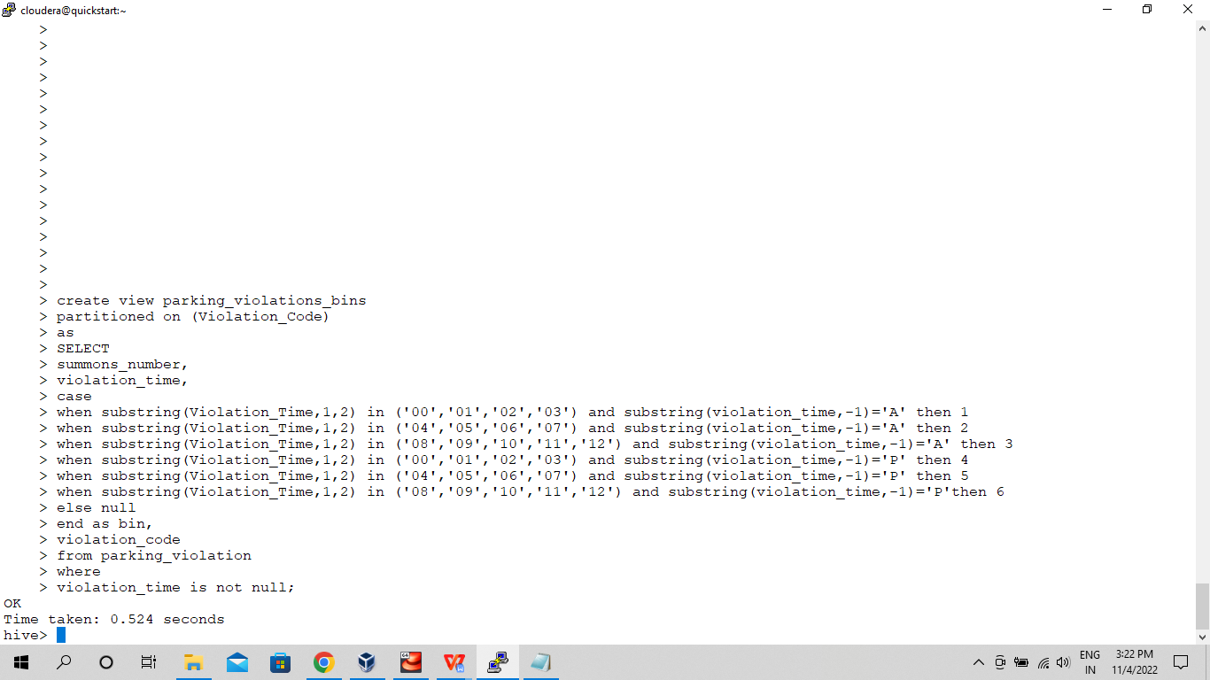

**Bin 1 -**

select violation_code, count(*) as occurence from parking_violations_bins where bin = '1' group by violation_code order by occurence desc limit 3;

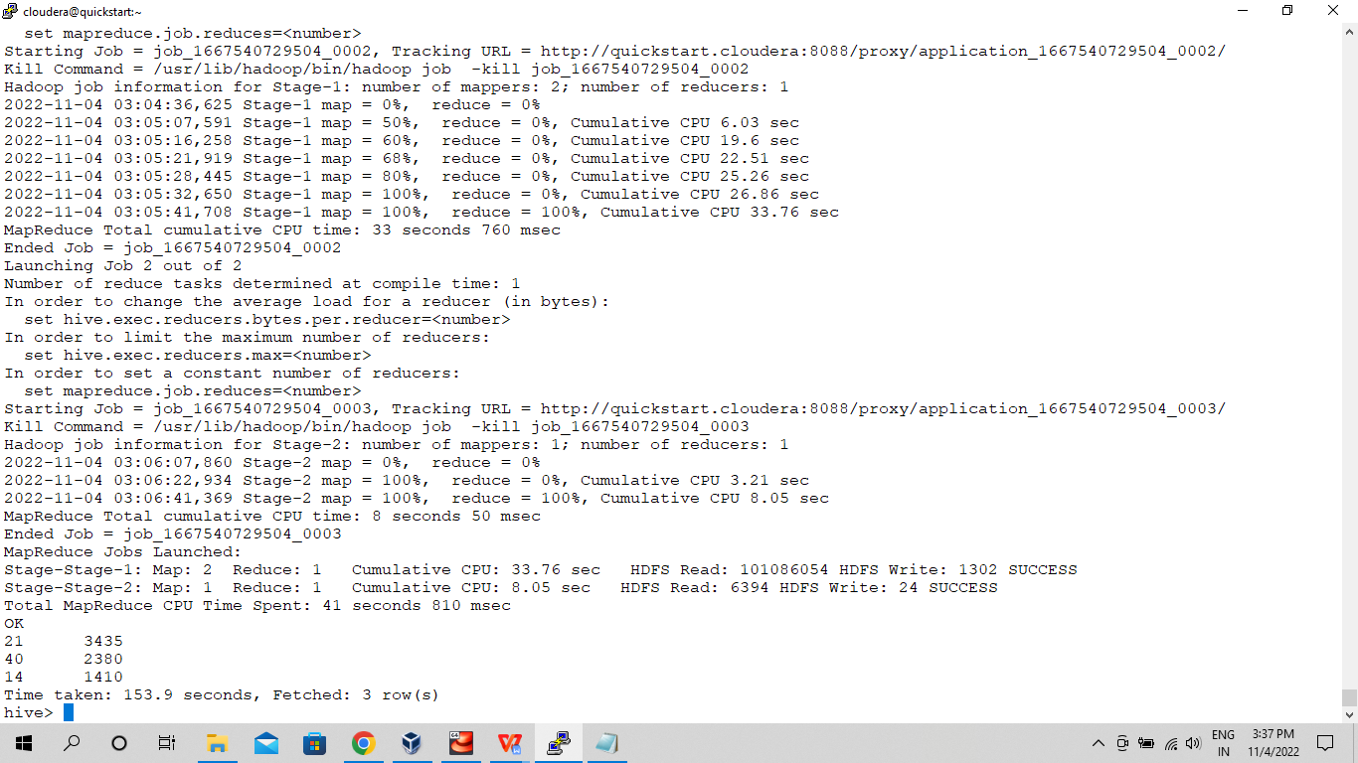

**Bin 2 -**

select violation_code, count(*) as occurence from parking_violations_bins where bin = '2' group by violation_code order by occurence desc limit 3;

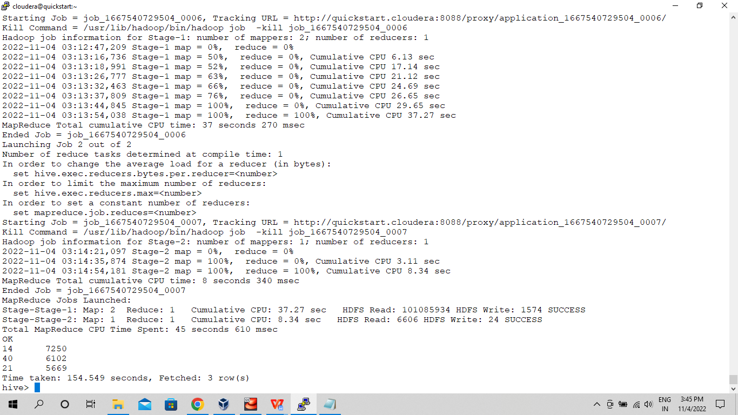

**Bin 3 -**

select violation_code, count(*) as occurence from parking_violations_bins where bin = '3' group by violation_code order by occurence desc limit 3;

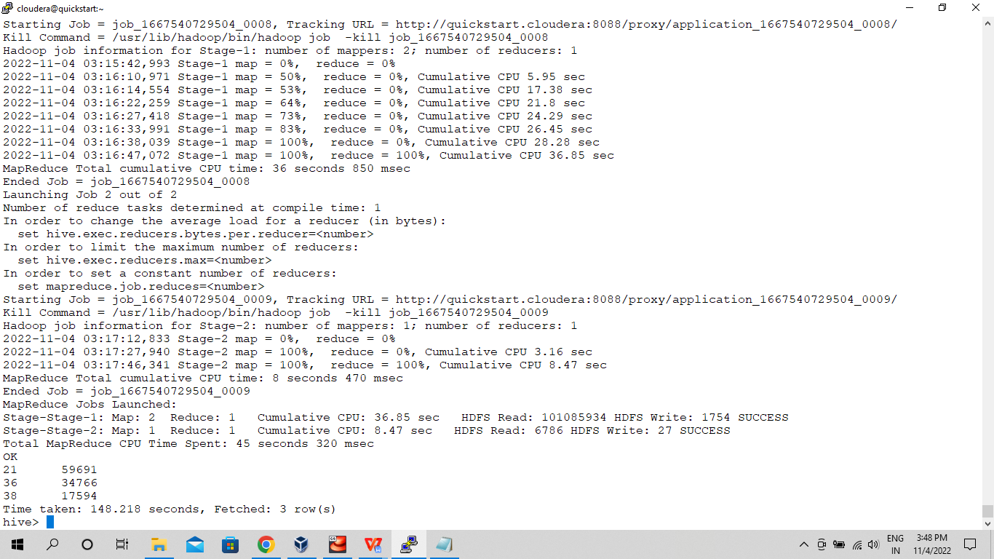

**Bin 4 -**

select violation_code, count(*) as occurence from parking_violations_bins where bin = '4' group by violation_code order by occurence desc limit 3;

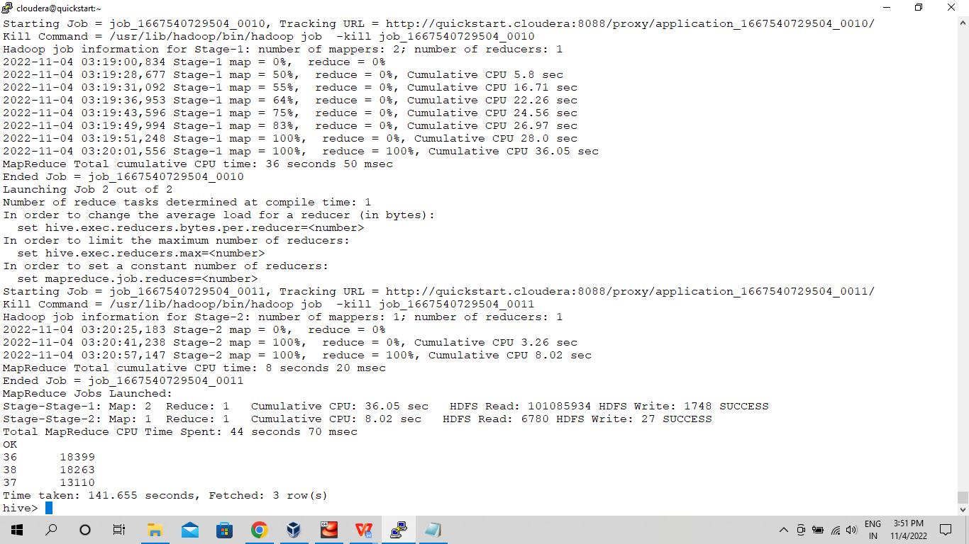

**Bin 5 -**

select violation_code, count(*) as occurence from parking_violations_bins where bin = '5' group by violation_code order by occurence desc limit 3;

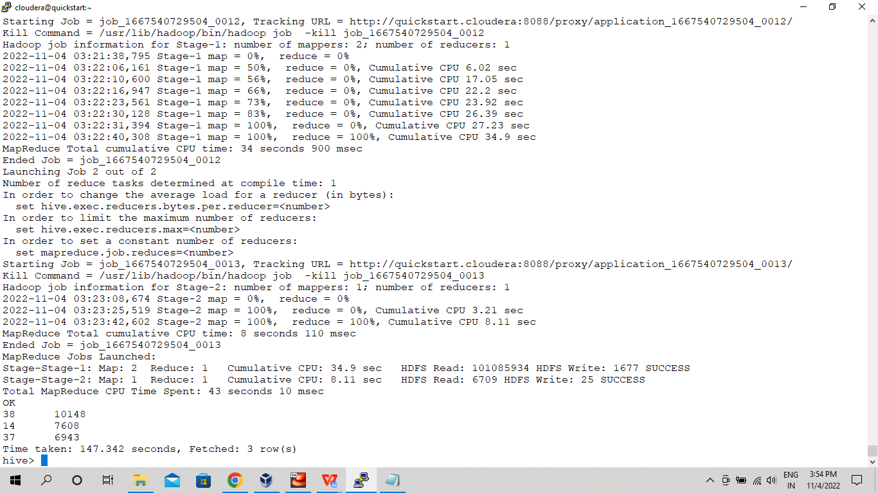

**Bin 6 -**

select violation_code, count(*) as occurence from parking_violations_bins where bin = '6' group by violation_code order by occurence desc limit 3;

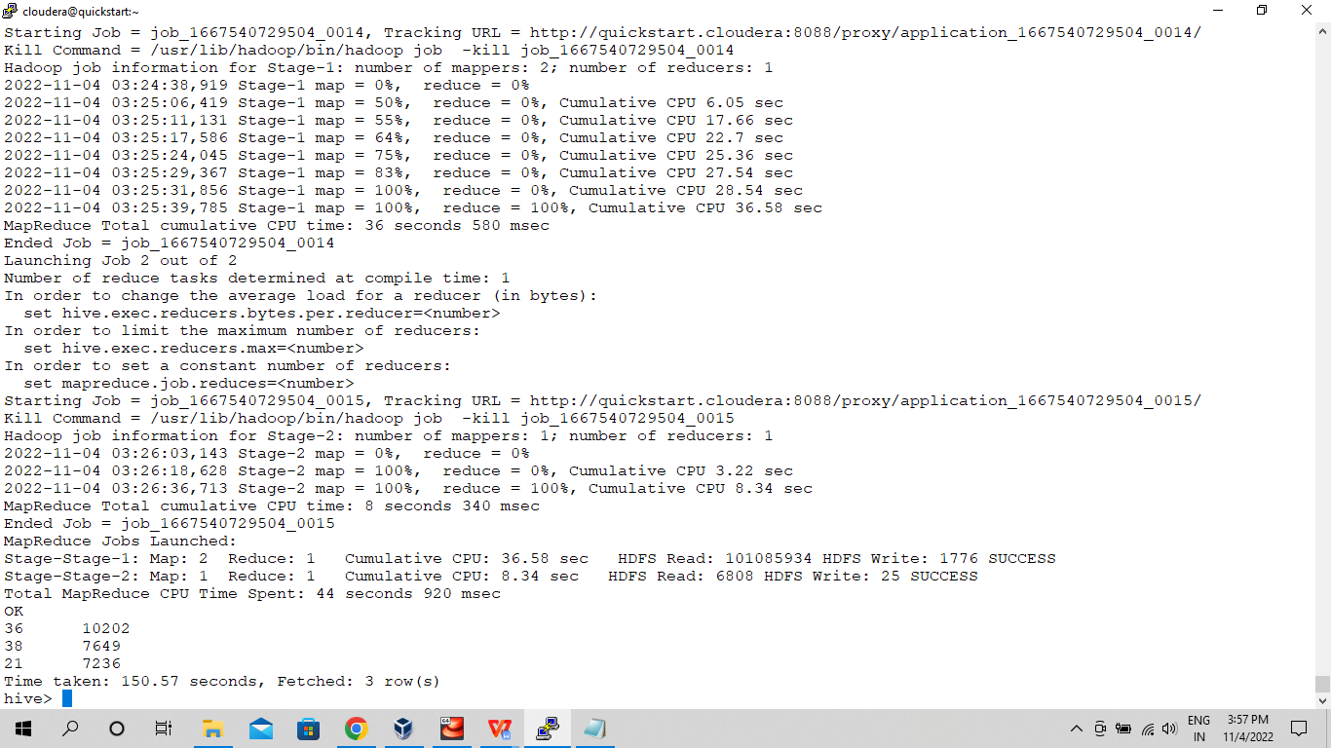

1. **Now, try another direction. For the 3 most commonly occurring violation codes, find the most common times of day (in terms of the bins from the previous part)**

select violation_code, count(*) as occurence from parking_violations_bins group by violation_code order by occurence desc limit 3;

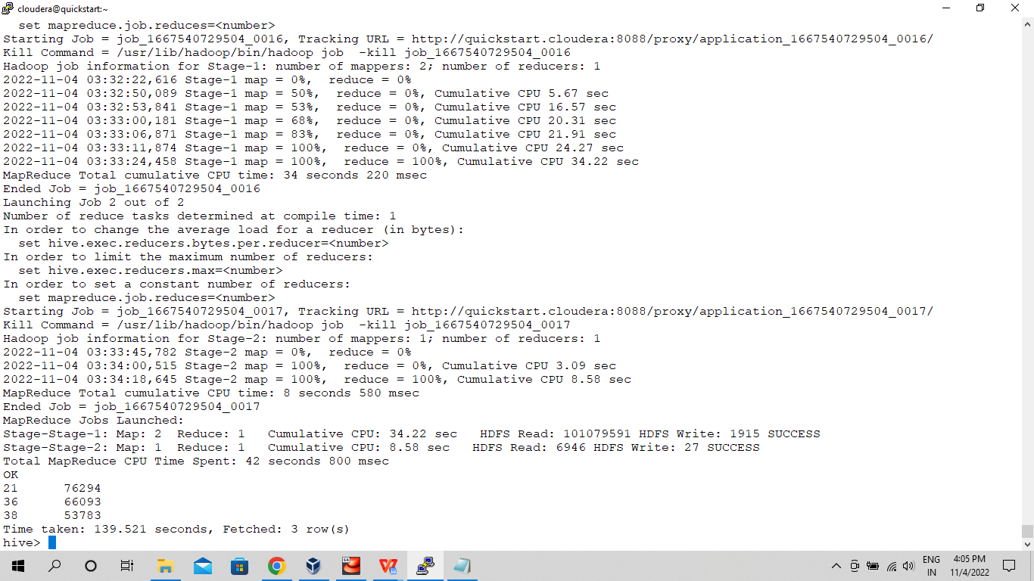

select violation_time, count(*) as frequency from parking_violations_bins where violation_code in ('21','36','38') group by violation_time order by frequency desc limit 3;

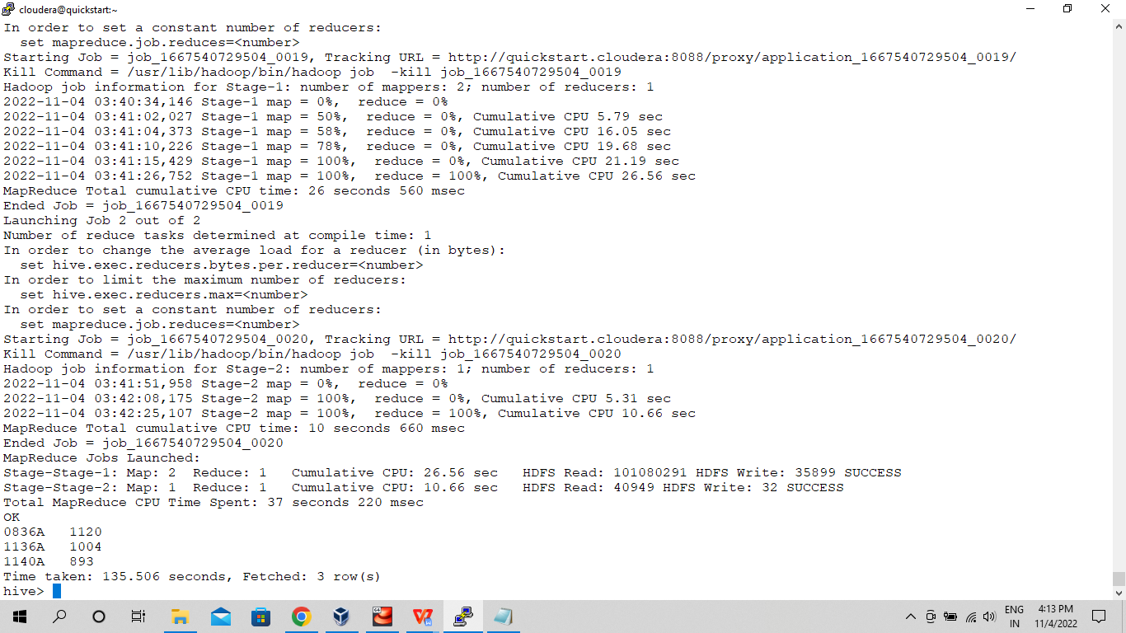

1. **Let’s try and find some seasonality in this data**
2. **First, divide the year into some number of seasons, and find frequencies of tickets for each season. (Hint: A quick Google search reveals the following seasons in NYC: Spring(March, April, March); Summer(June, July, August); Fall(September, October, November); Winter(December, January, February))**

create view parking_violations_seasons

partitioned on (Violation_Code)

as

SELECT

summons_number,

case

when month(issue_date) between '03' and '05' then 'spring'

when month(issue_date) between '06' and '08' then 'summer'

when month(issue_date) between '09' and '11' then 'fall'

when month(issue_date) in ('1','2','12') then 'winter'

else null

end as season,

violation_code

from parking_violation;

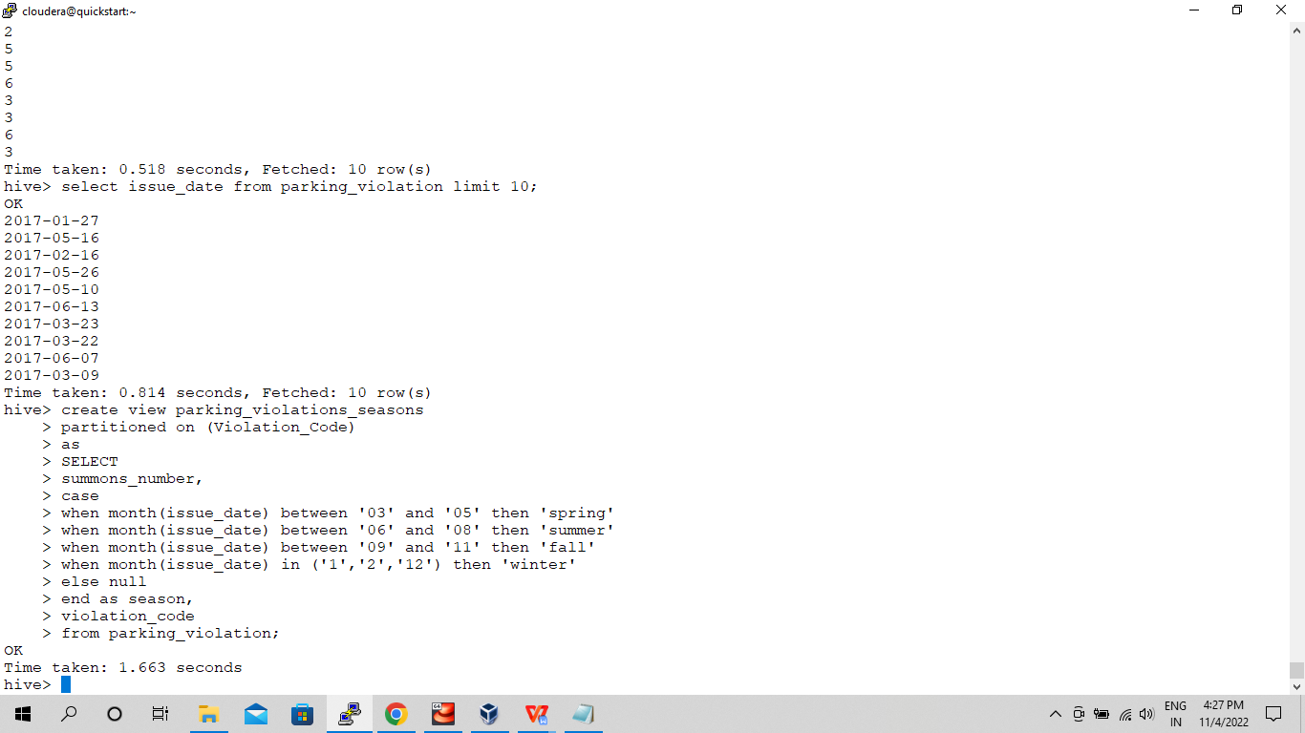

**Spring -**

select season, count(*) from parking_violations_seasons where season = 'spring' group by season;

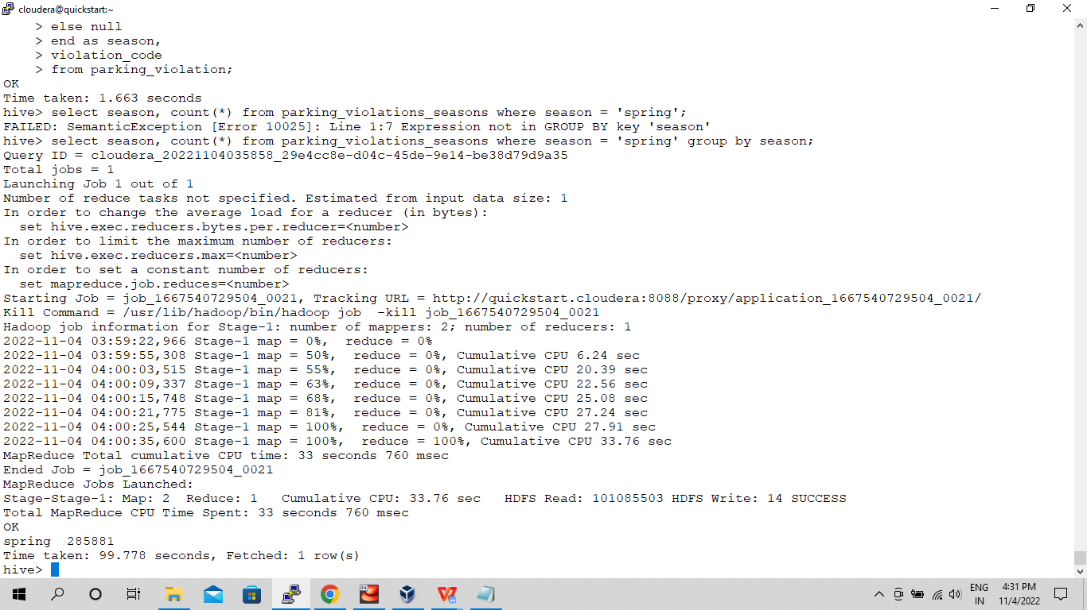

**Summer -**

select season, count(*) from parking_violations_seasons where season = 'summer' group by season; 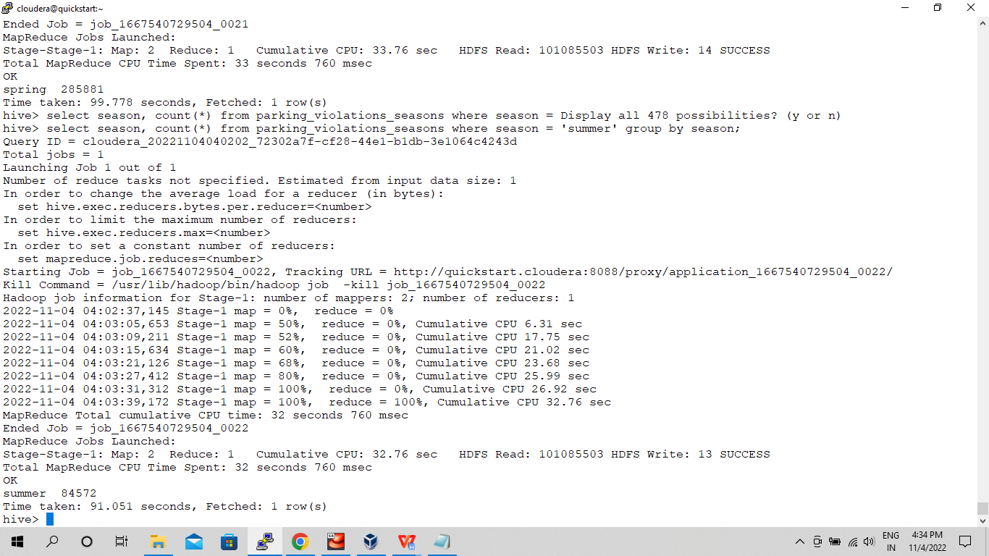

**Fall -**

select season, count(*) from parking_violations_seasons where season = 'fall' group by season;

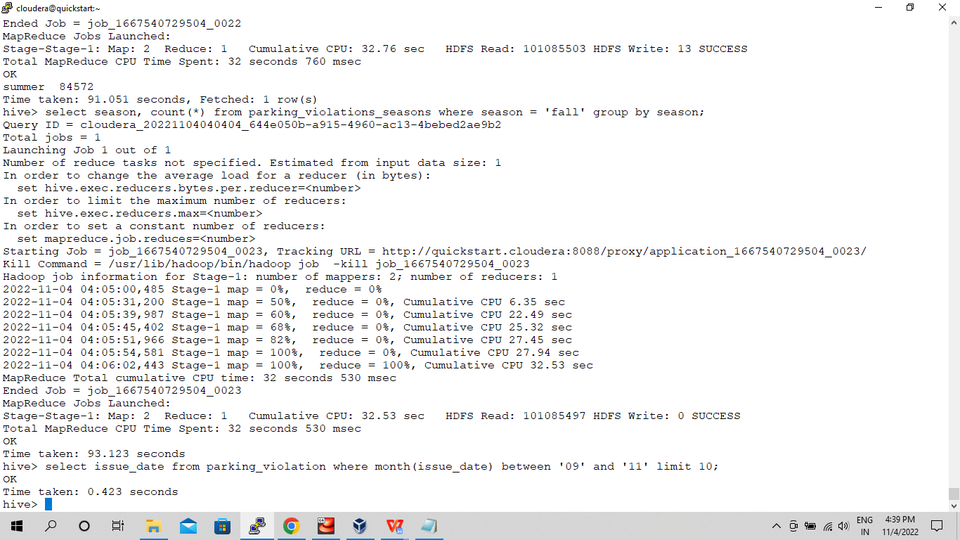

**Winter** -

select season, count(*) from parking_violations_seasons where season = 'winter' group by season;

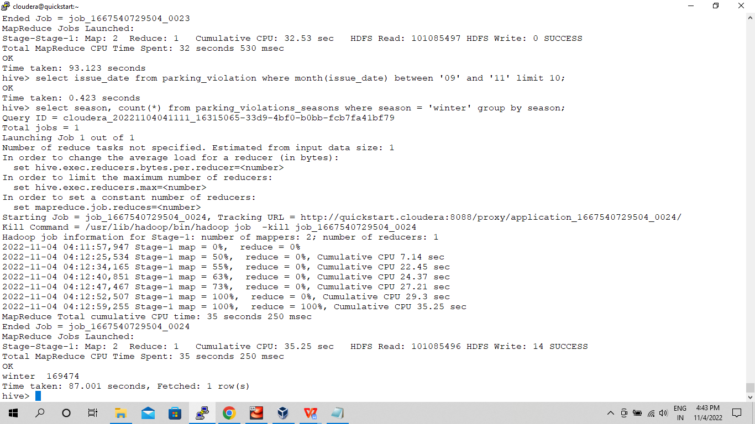

1. **Then, find the 3 most common violations for each of these seasons.**

**Spring -**

select violation_code, count(*) as frequency from parking_violations_seasons where season = 'spring' group by violation_code order by frequency desc limit 3;

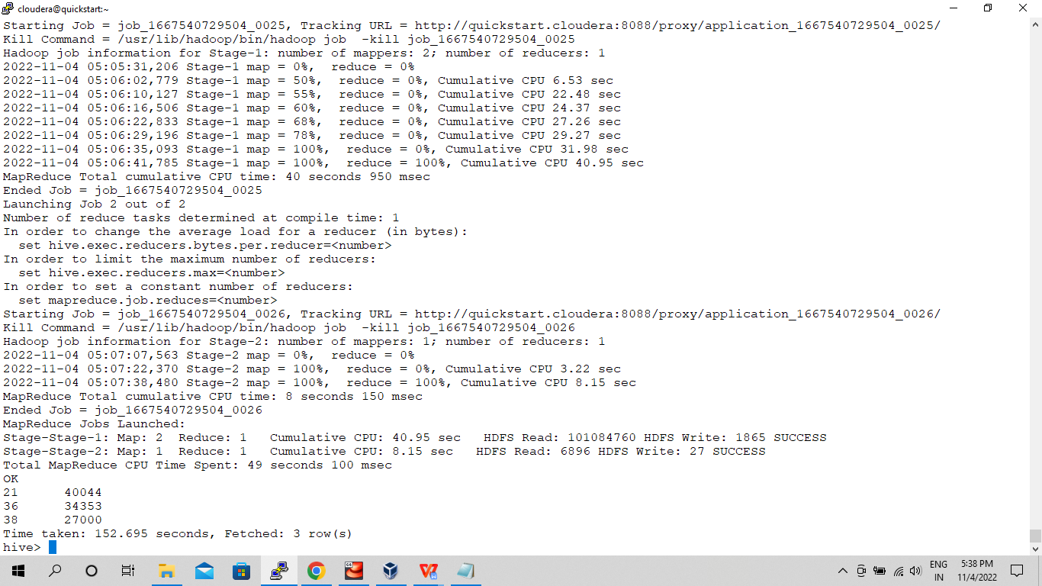

**Summer -**

select violation_code, count(*) as frequency from parking_violations_seasons where season = 'summer' group by violation_code order by frequency desc limit 3;

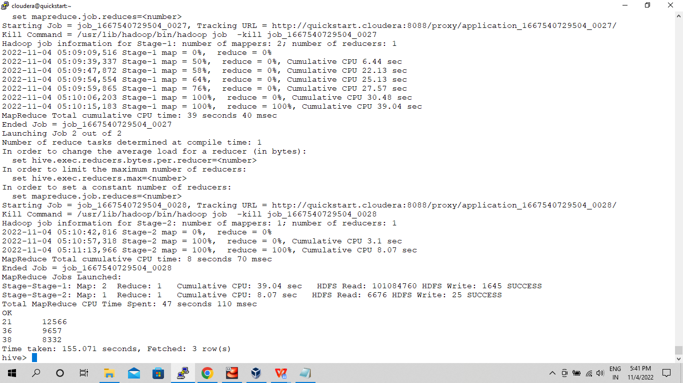

**Fall -**

select violation_code, count(*) as frequency from parking_violations_seasons where season = 'fall' group by violation_code order by frequency desc limit 3;

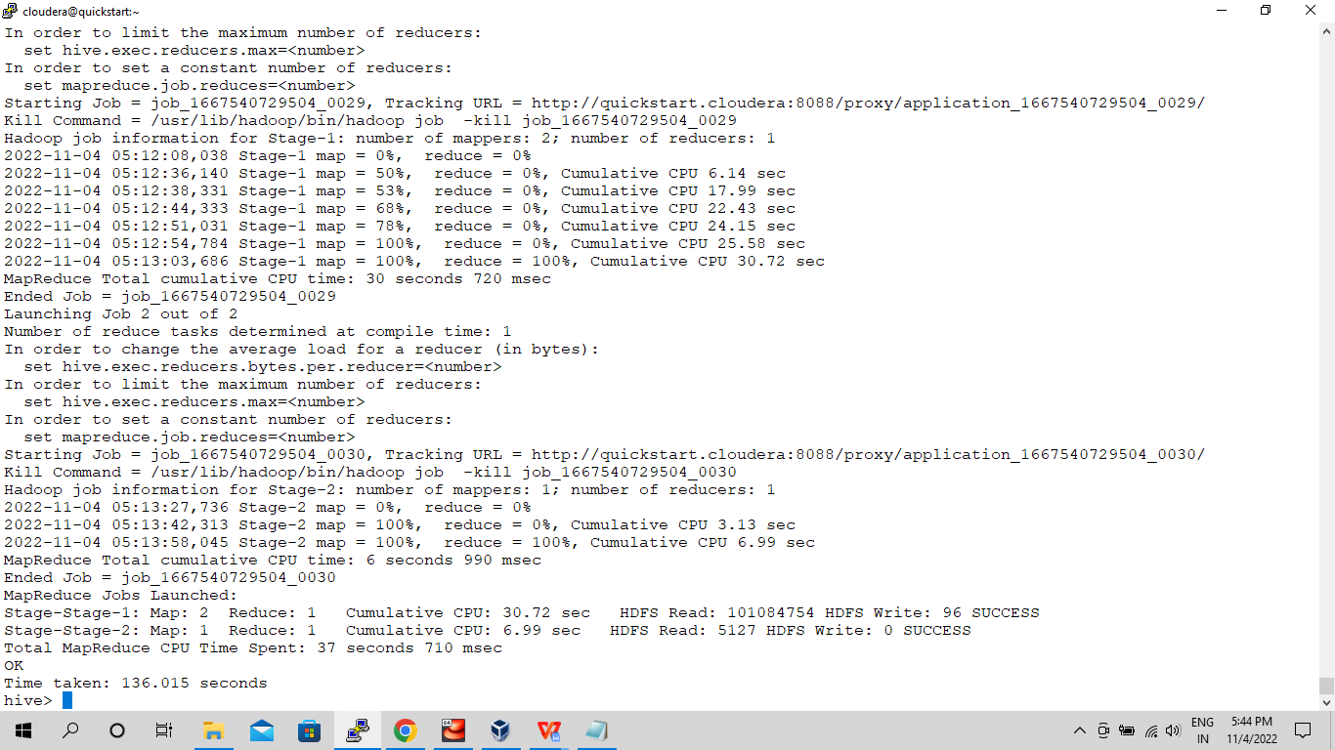

**Winter -**

select violation_code, count(*) as frequency from parking_violations_seasons where season = 'winter' group by violation_code order by frequency desc limit 3;

